SIH 2019

**A PROJECT REPORT**

***Submitted by***

**PANDA CODERS**



**PROBLEM STATEMENT(MINDTREE): LB5**

***“MECHANISM TO SAVE MEDICINE FROM GETTING WASTED”***

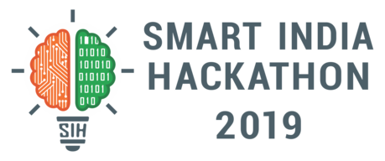

**INDEX**

1. INTRODUCTION
2. NEED
3. SOLUTION APPROACH
4. PROTOTYPE MODEL
5. IMPLEMENTATION
6. USE CASE
7. DATA FLOW DIAGRAM
   1. DFD level 0
   2. DFD level 1
   3. DFD level 2 : Collection of Medicine
   4. DFD level 2 : Donating Medicines
8. CONCLUSION FROM SURVEY
9. CHALLENGES
   1. Uncategorized Medicines
   2. Expired Medicines
   3. Proper Validation
   4. Medicine Given to the Recipient causes side effects
   5. Laziness of people
10. CONCLUSION
11. **INTRODUCTION:**

Our problem is to find a mechanism to save medicines from getting wasted. We can view this problem in following aspects:

* The medicines which are expired are just thrown in the garbage which actually leads to environment degradation. According to the survey done, 550 tons of medicine waste is generated every day and it might reach to 770 tons in 2022.This waste actually harms the health of the society as well as our planet.
* People do not use the medicine properly. They just keep their unused medicine in the drawer till they expire or could be used again .This ignorance of people leads to the wastage of the medicines. Rather than this these medicines could be given to the needy ones. According to the recent Healthcare Research 7,000 people die yearly due to not getting the proper treatment.
* Sometimes in the middle of taking the course of medicine, the patient gets well. Thus the medicines remain unused.
* People change their doctors frequently due to which the medicine left is unused. On changing doctors, the medicines get changed and now the patient needs to buy new medicines due to which he/she ends up with having many unused medicines.
* Sometimes some doctors just experiments on us, after prescribing the medicine they just change them, due to which earlier prescribed medicines get wasted.
* If the patient dies in between his medical course, the medicine are left unused.

1. **NEED:**

The problems and requirements which motivates us to make this web-application are as follows :

* As the large number of medicines do get wasted every day in the nationwide so there is a must need to save these medicines as these medicines can help the needy ones.
* In India, around 7000 people die every year due to not getting the medicines because they can’t afford it due to high cost so to save lives of these people a solution is needed.
* To upgrade more and more users and to fill the communication gap between the donor and the recipient.
* The people lives in the rural areas does not get the medicines on time as there are no or some pharmacy present in their locality and if pharmacies are available then there is no such amount of medicines which can fulfill the needs of the customer.
* To make people aware about their unused medicines and to provoke them for doing social works.
* To reduce the number of deaths caused due to lack of medicines.
* The medicines which are expired leads to environment degradation and pollute the surrounding. To properly decompose those medicines , we need to build this app.

1. **SOLUTION APPROACH:**

* Life of a human being is very precious which must be saved at any cost. Here at our web-application named “PatientSakhi”, we pride ourselves in delivering unexpired surplus medicines to low-income patients in an efficient way and in minimum possible time so that their valuable lives can be saved.
* Our platform connects patients to the surplus medicines lying in the drawers of more than 70% people in India in a convenient way. We collect the surplus unused medicines from individuals . Unexpired medicines are then delivered to the needed ones and the expired medicines are then disposed off in a correct way to avoid any kind of environmental pollution.
* Our web-application works on the collective wellbeing of the society. It Motivates people to donate those medicines which are useless for them but can be used by someone else . This could only be possible if we all join hands to devote us for social cause.
* Many people have unused medicines at their homes which are of no use for them. On the other side, many people remain deprived of medicines which they require due to lack of money. This gap is called information gap. Our web-application fills this information gap.
* In this web-app , we are working for the society , so anyone who wishes to work with us can join us as an helper. As Swach Bharat Abhiyan is based on the social cause and could only be worked out if all people help . In the same way , this approach also requires the collective effort of the people. Today the people’s lifestyle is so busy and changed that they did not find time to devote their time in social work.

1. **PROTOTYPE MODEL:**

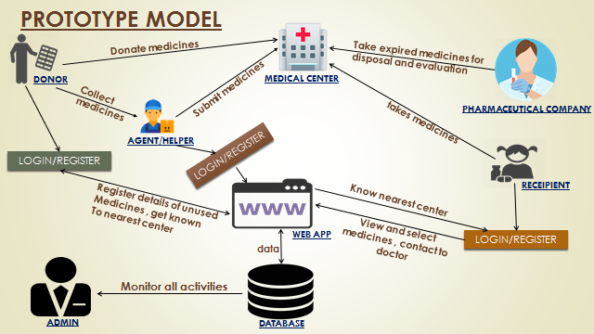

**5. IMPLEMENTATION**:

* **USER :** There are two types of users which can connect to our web-application. These are :

1. Donor
2. Recipient
3. **DONOR :** The donors are the users who donates the unutilised medicines stored in their homes using the web-application. They donate medicines for low-income people (Below Poverty Line) if he wants. For donating medicines they first need to register themselves on the app. Then they provide the minimal details of the medicines they want to donate. Donation of illegal drugs is not entertained and if found, severe actions will be taken.
4. **RECIPIENT :** The recipient are the users or patients who wants the medicines from the web-application. The recipient can get these medicines for free if he/she is below poverty line. For recieving medicines they first need to register themselves on the app. For high dosed medicines (prescription drugs), the recipient have to attach the prescription of the doctor.

There are many other users of this web-application which completes this chain of medicines from the donor to the recipient. These users are :

* **MEDICINE STOCK CENTRES :** Medicine Stock Centres are the hospitals and pharmaceutical shops that keeps the stock of medicines donated by the people. The people who want to donate medicines have to submit the medicines at these centres and also the people who want to take these medicines have to come to these centres for receiving them .
* **AGENTS :** Agents are those people who help our website by collecting medicines from those donors who want to donate medicines but unable to come to the centres for submitting them. People who are interested in doing social service can work as an agent for the app. They can collect medicines from those people who lies in between their daily route and then submit them at the centres.
* **PHARMACEUTICAL COMPANIES :** A Pharmaceutical company is a commercial business licensed to research, develop and/or distribute medicines, most commonly in the context of healthcare. All the expired medicines are sent to these companies for the safe disposal so that the environmental pollution can be avoided.

**6.USE CASE:**

An **entity–relationship model** (**ER model** ) describes interrelated things of interest in a specific domain of knowledge. A basic ER model is composed of entity types (which classify the things of interest) and specifies relationships that can exist between instances of those entity types.

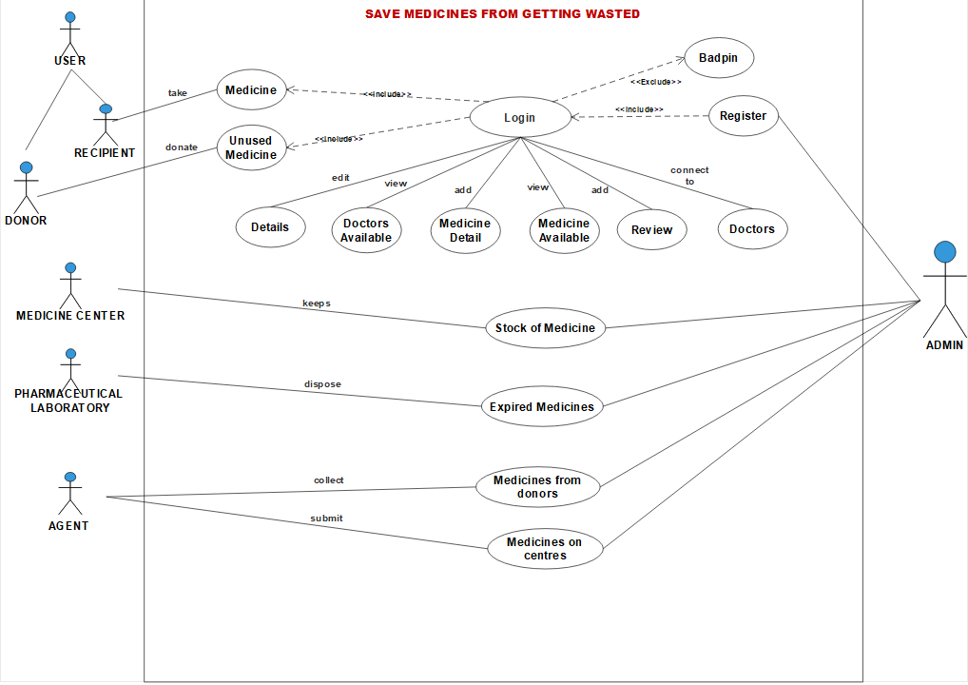

**7.DATA FLOW DIAGRAM:**

* 1. **DFD level 0 :-**

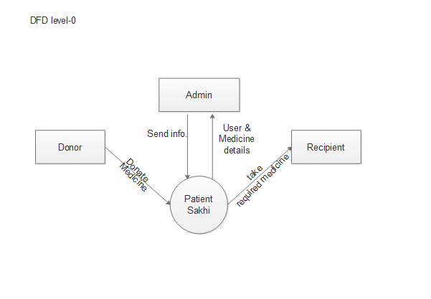

* 1. **DFD LEVEL 1:**

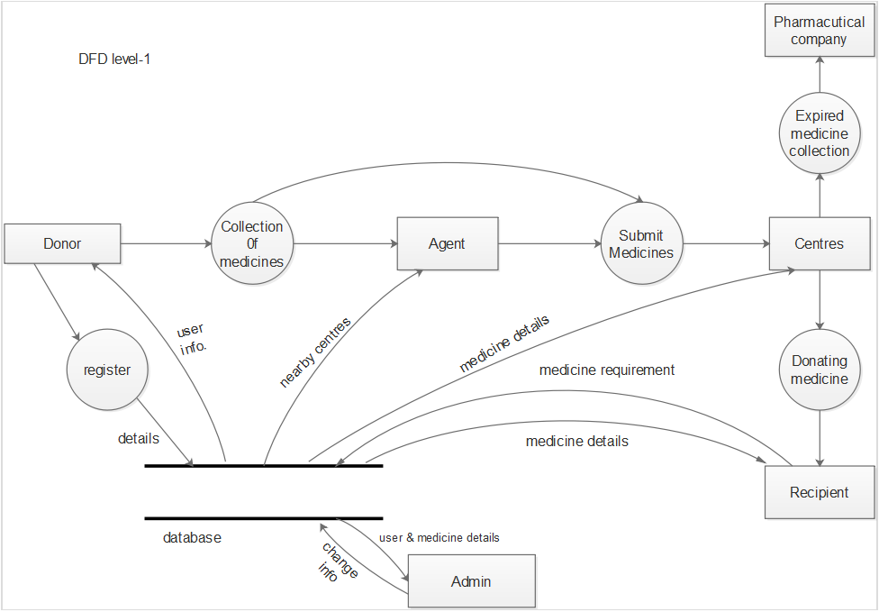

* 1. **DFD LEVEL 2: COLLECTION OF MEDICINES**

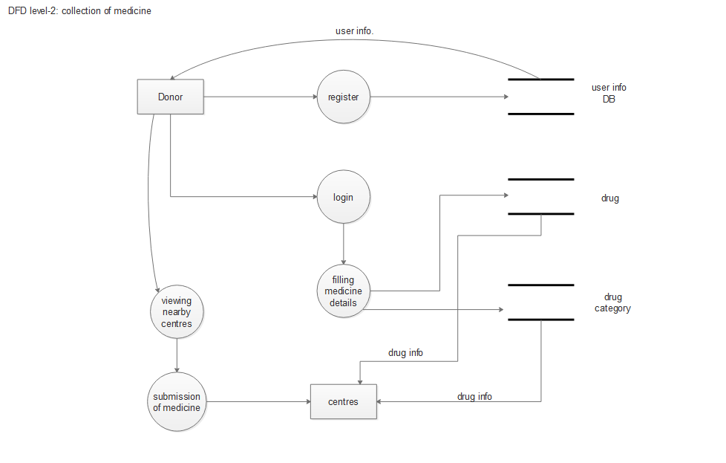

* 1. **DFD LEVEL 2: DONATING MEDICINES**

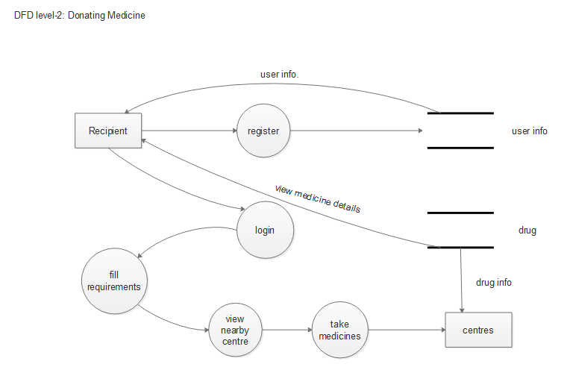

1. **CONCLUSION FROM SURVEY :**

* We had conducted a survey in our locality before this SIH Hackathon 2019 and we found many things related to our problem statement. Here is the survey report as follows:
* **Pharmacy**

Pharmacies accept many unused medicines from the customers, only when they provide the bill. The medicines which get expired and are in the range of within 6 months are sent back to the companies and if expiration date crosses 6 months then they are sent to the labs for the disposal process. The pharmacies take both injections and oral medicines. Pharmacies decide the quantity of medicine according to the past demand and on the prediction basis.

* **Society**

In the society survey we found that every person keeps medicines at their home it can be either antibiotic or syrups or any other small disease medicine.

Most of the people like to consult to a doctor before taking any medicine. Almost 90% of People are willing to donate their unused medicines but the issue is that they have very much busy schedule that even they don’t know how many medicine is of their use and how many are waste. We have predicted from the survey that 80% of people want to donate the medicine for free but rest 20% want to sell their medicine at moderate price.

1. **CHALLENGES:**
   1. **UNCATEGORIZED MEDICINES:**

Uncategorized medicines means the user who will donate the medicines doesn’t know the basic details of that medicine such as its name, expiry date or something else. While donating , the donor may find the problem that his medicine strip may not contain the relevant details , so it becomes difficult for him to fill in the details.

**Solution**:

The donor has to simple register and fill all the details about the medicines, whatever he/she knows and the unknown credentials can be left empty(or set to others).Now, after reaching the medical centre , the pharmaceutical people can determine the name of the medicine just by looking to the salts or other information on the strip.

Then, medicines are sent to the pharmaceutical labs where they can find if the medicine is expired or not. According to our survey, a small clue is enough to find the history of that medicine. If expired then sent for disposal and if not then it is sent to company where we can get in return similar medicines and can add to our stock.

This approach increases our stock number and adds other medicines too.

* 1. **EXPIRED MEDICINES:**

If the donor donate the expired medicine to the medical centre. How are these medicines further processed by the medical centre?

**Solution**:

The solution of this problem is that the medicines which has no details mentioned on it/ expired , these medicines are given to the labs where it is checked. The details are obtained from that research such as name of the medicine, expiry date and all other necessary details. If the medicine is found expired and expiration date crosses the limit of 6 months, then these medicines are disposed otherwise they are given to their respective companies. And in exchange we can get similar types of medicines.

* 1. **PROPER VALIDATION:**

Proper validation of the medicines is required because if no validation of any medicine is done then it may lead to a big problem. Any user can log in into the web-app and can give the fake medicine or the drug which can harm the health of the recipient, so there is a requirement of a mechanism for proper validation of medicines.

**Solution**:

The solution is that we will accept all type of medicines and after getting submitted at the medical centre by the donor, these medicines will be examined by the pharmaceutical people. Only after validating the medicine , that particular medicine will be added to the stock. And for recipient , prescription is mandatory.

* 1. **MEDICINE GIVEN TO THE RECEPIENT CAUSES SIDE EFFECTS:**

This is the most important cause to think over that what to do if the medicine given by your web-app harms the recipient’s health or leads to its death. How would you resolve this problem?

**Solution**:

In our view this is not a problem as we have mentioned in starting only that we will accept medicine from donor but we will not give the medicine to the recipient without seeing the Doctor’s prescription so if this prescription causes you harm then this is not the responsibility of our app and the medicines which we will give over the counter will be some kind of antibiotic medicines. Since our app is licensed so our medicines will be safe and healthy for users.

* 1. **LAZINESS OF PEOPLE:**
* **PROBLEM 1 :** There are some problems due to which people don’t submit the medicines at the medical stock centers .These problems are :**-**
  + - * + People are so busy in their daily schedules that they want to donate the medicines but they do not have time to go and submit these medicines to the medical stock centers .
        + They always postpone their work on tomorrow.
        + They don’t have conveyance to the medical centres.
        + They are old or handicapped so unable to go to the centres.

**Solution**:

We have find various solutions which can overcome this problem :-

* + - * + Any responsible person can collect medicines from all the houses of his locality where people want to donate . He then submit these medicines at the medical centres lying in between his way to his office or college.
        + The people who want to connect with us for a social cause can acts as a transporter for collecting medicines for homes and submitting them at the centres.
* **PROBLEM 2:** People are so much lazy that they do not want to fill a lot of medicine details for just submitting a few medicines. So they refuse to donate medicines and the medicines left unused at their homes.

**Solution**:

For solving this problem we are taking a very few medicine details and personal details which anyone can fill easily in seconds . The details we are taking are below :-

* + - * + Name of Medicine
        + Quantity of Medicine the donor wants to donate
        + Expiry date of the medicines
        + Address of the user

1. **CONCLUSION:**

The project is identified by the merits of the system offered to the user. The merits of this project are as follows :

* It is a responsive web app , i.e. it can run on any size gadget like laptop , tablet , mobile phone etc.
* This web-application bridges the information gap between the medicines and the needy people.
* This web-application provides a simple platform that connects the unused medicines lying at the homes to the people who really need this but can’t afford to buy.
* User is provided with the option of forget password as if he forgets his password he can change it by entering the email address.
* Very easy to use , i.e. user friendly .